Automatic Thyroid Ultrasound Image Classification Using Feature Fusion Network

**ABSTRACT:** Today, the majority of thyroid nodule diagnoses are made through clinical techniques, which demand a significant amount of personnel & medical equipment. In order to diagnose thyroid ultrasonography nodules automatically, this paper presents a method that combines image texture information & convolutional neural networks. The key actions consist of: By gathering both positive & negative samples, normalising the pictures, & segmenting the nodule area, the ultrasonography thyroid nodule dataset is first created. Second, a texture features model is created through the extraction of texture features, feature selection, & data dimensionality reduction; Thirdly, a deep neural network is employed to obtain a feature representation of the nodule in photos by transfer learning; Then, a new nodule feature model called Feature Fusion Network is created by fusing the texture & convolutional neural network feature models; Finally, a deep neural network diagnosis model that can adjust to the characteristics of thyroid nodules is created using the Feature Fusion Network to train & improve performance over a single network. 1874 groups of clinical ultrasonography thyroid nodules are gathered in order to test this technique. The Precision & Recall-based Harmonic Average F-score is utilised as a measurement tool. According to experimental findings, the Feature Fusion Network can identify benign from malignant thyroid nodules with an F-score of 92.52%. This work performs better than convolutional neural networks & conventional machine learning techniques.

***Keywords*** *– Machine learning methods, convolutional neural network.*

1. **INTRODUCTION**

Thyroid nodules are becoming more common worldwide as a result of rising human life strain. It has grown to be among the most serious illnesses & is endangering human health [1]. Therefore, it is crucial to diagnose thyroid nodules as soon as possible [2]. The most common aspiration biopsy, CT scan, ultrasound, & pathological examinations used to diagnose thyroid nodules. Nuclear scanning, which is necessary for a CT exam but expensive & dangerous to patients, is required. Despite being more widely used & accurate methods, needle biopsy & pathological examination cause significant stress to thyroid tissue. Additionally, the lengthy nature of their diagnosis will require extra medical resources. The most popular imaging technique used nowadays to diagnose thyroid disorders is ultrasound. Its benefits include speed, affordability, non-invasiveness, repeatability, & simplicity. Normally, clinicians can decide harmless & threatening circumstances in view of their clinical mastery, which is exceptionally individualized & defenseless to predisposition. Accordingly, it has become all the more desperately important to have the option to successfully & quickly distinguish & analyze the pathology of ultrasonography thyroid knobs. Man-made brainpower innovation has continuously become more common in medication during the beyond couple of years, especially in the fields of imaging [3]-[5] & signal [6]. One critical area of current review is the way to fabricate a PC helped robotized thyroid determination framework utilizing data from ultrasound pictures [7], [8]. Utilization of elements extraction designing & classifiers for characterization to support clinical diagnostics is a predominant practice. For example, Zheng et al [9] utilization of LR (Calculated Relapse) to kill factors that affected recognizing harmless & destructive thyroid was effective. This regression models can classify photos in a pathological manner. In order to diagnose thyroid nodules, Liu et al. collected local texture data from the region of interest & used the KNN (K-Nearest Neighbor) method. To aid medical professionals in detection using classifiers based on genetic planning, Choi & Choi developed thresholds & 3D connected region labelling techniques. These technologies establish precise computer diagnosis techniques & are based on computer theoretical systems. However, it depends on how complete the information about the feature textures is & how well the classifier is chosen.

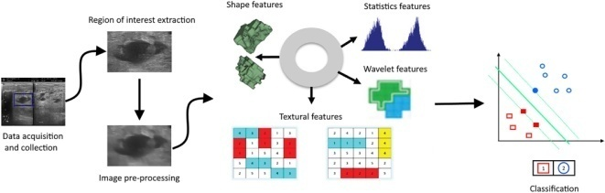

Fig.1: Example figure

1. **LITERATURE REVIEW**

**Geographic influences in the global rise of thyroid cancer:**

Thyroid malignant growth is supposed to surpass different tumors as the fourth most normal all around the world as the recurrence of the illness rises. The age-normalized occurrence pace of thyroid disease expanded by 20% around the world between 1990 & 2013. The upgraded conclusion of early cancers, the more noteworthy predominance of modifiable individual gamble factors (such heftiness), & the expanded openness to natural gamble factors have all been ensnared in this worldwide expansion in occurrence (for instance, iodine levels). In this survey, we explore laid out & new hypotheses for how ecological openings & modifiable gamble variables might be adding to the worldwide ascent in thyroid disease rate. In certain locales of the world, overscreening & the expanded determination of illnesses that may not be clinically significant may play a commitment, but rather in different districts, expanding openness dangers may really be adding to an ascent in frequency. Public & overall vault information ought to be utilized in the ongoing time of tweaked medication to distinguish populaces that are bound to foster thyroid malignant growth.

**Improving the accuracy of early diagnosis of thyroid nodule type based on the SCAD method**

Although early determination of the thyroid knob type is critical, the symptomatic viability of traditional diagnostics is a troublesome issue. Here, we tried to recognize an optimal arrangement of factors to upgrade demonstrative accuracy for isolating harmless from dangerous thyroid knobs before medical procedure. 345 thyroidectomy references from 2008 to 2012 were remembered for an imminent exploration. With a proportion of 7:3, the example size was isolated into preparing & testing gatherings. The previous was applied to gauge, variable determination, & figure blend a straight style. To arrive at the meager ideal mix of parts, we utilized smoothly clipped absolute deviation (SCAD) strategic relapse. Utilizing a receiver operating characteristic (ROC) bend, the assessed model's exhibition in the testing set was evaluated. The 279 female & 66 male patients who went through assessments had a typical period of 40.9 13.4 years (range 15-90 years). A sum of 54.8% of the patients (24.3% men, 75.7% ladies) had harmless thyroid knobs, while 45.2% (14% men, 86% ladies) had threatening thyroid knobs. Notwithstanding knob & curve greatest widths, their volumes were thought about as significant measures for threat expectation (a sum of 16 variables). The SCAD strategy, nonetheless, anticipated that the coefficients of 8 components were zero & taken out them from the model. Subsequently, a meager model was made to integrate the impacts of 8 boundaries to recognize dangerous & harmless thyroid knobs. For our assessed model, we had the option to decide the ROC bend's ideal endpoint (p=0.44), & the region under the bend (AUC) was determined to be 77% (95% CI: 68%-85%). For this model, the relative responsiveness, explicitness, positive prescient worth, & negative prescient worth were 70%, 72%, 71%, & 76%. The discoveries of the measurable demonstrating approaches were viewed as valuable in the early conclusion of thyroid knob type, expanding by 10% & having a higher exactness rate when contrasted with the consequences of FNA testing (SCAD & ANN strategies). Also, the component positioning given by these methods is helpful in the clinical setting.

**A review of medical image detection for cancers in digestive system based on artificial intelligence**

As of now, malignant growth imaging assessments are fundamentally performed physically by specialists, requiring an elevated degree of the specialists' expert skill, clinical experience, & concentration. Radiologists, nonetheless, are confronting a rising number of troubles because of the developing volume of clinical imaging information. An answer for the programmed examination of clinical pictures can be found with the discovery of digestive system cancer (DSC) in light of man-made brainpower (artificial intelligence), which can likewise assist specialists with making high-accuracy, savvy malignant growth analyze. locales covered The essential target of this study is to make sense of the vital philosophies for the simulated intelligence based location of DSC & to act as a helpful asset for scientists. Meanwhile, it features the main points of contention with current procedures & offers better course for future review. Master investigation: The methods of AI & profound realizing, which lessen the inward data of pictures that is hard for people to uncover, can all the more likely achieve the programmed grouping, acknowledgment, & division of DSC. The use of simulated intelligence to help imaging specialists in the conclusion of DSC can rapidly & really distinguish malignant growth & decrease how much time it takes for clinicians to make a finding. These can act as the foundation for more exact clinical determination, treatment arranging, & quantitative DSC assessment.

**An intelligent platform for ultrasound diagnosis of thyroid nodules**

This review recommended using B mode ultrasound information a non-division radiological technique for grouping harmless & threatening thyroid malignant growths. With this methodology, the advantages of morphological information from ultrasonography & convolutional brain networks were consolidated for programmed highlight extraction & exact order. Rather than the traditional element extraction strategy, this technique extricated includes straightforwardly from the informational collection without the prerequisite for human methodology or division. For the end goal of preparing, 861 photographs of harmless knobs & 740 photos of malignant knobs were assembled. A profound convolution brain network called VGG-16 was worked to evaluate test information, which included 100 photographs of dangerous knobs & 109 pictures of harmless knobs. The classifier was prepared & tried utilizing a nine crease cross approval. The examination uncovered that the strategy's exactness, responsiveness, & particularity were all 86.12%, 87%, & 85.32% individually. The exactness, awareness, & explicitness of this PC supported approach were comparable to those revealed by an accomplished radiologist utilizing the thyroid imaging reporting & data system (ACR TI-RADS) (precision: 87.56%, responsiveness: 92%, & particularity: 83.49%). The technique's robotization benefit showed potential for use in PC helped thyroid disease diagnostics.

**Automatic thyroid nodule recognition & diagnosis in ultrasound imaging with the YOLOv2 neural network**

Foundation In this review, photographs of 2450 harmless thyroid knobs & 2557 threatening thyroid knobs were assembled & classified, & a profound learning framework called the YOLOv2 brain network was utilized to fabricate an independent picture acknowledgment & demonstrative framework. The framework's adequacy in diagnosing thyroid knobs was surveyed, & the utilization of computerized reasoning in clinical settings was investigated. Techniques 276 patients' ultrasound pictures were reflectively picked. The pictures were consequently distinguished & analyzed utilizing the laid out man-made reasoning framework, & the radiologists' determinations depended on the Thyroid Imaging Detailing & Information Framework. The authoritative determination was made in view of obsessive examination. Results The injury district was effectively perceived by the man-made brainpower conclusion framework with a receiver operating characteristic (ROC) bend region under the bend of 0.902, which is more prominent than that of the radiologists (0.859). This outcome recommends a more serious level of symptomatic accuracy (p = 0.0434). The computerized reasoning determination framework's exhibition didn't significantly contrast from that of the radiologists (p > 0.05) regarding responsiveness, positive prescient worth, negative prescient worth, & exactness for the ID of threatening thyroid knobs. The explicitness of the simulated intelligence conclusion framework was more noteworthy (89.91% versus 77.98%, p = 0.026). Ends the man-made reasoning framework performs much the same way to experienced radiologists with regards to responsiveness & exactness for the conclusion of harmful thyroid knobs & performs better for the determination of harmless thyroid knobs. This computerized reasoning determination framework can help radiologists adequately in the finding of harmless & threatening thyroid knobs as an adjunctive device.

**3. METHODOLOGY**

Convolutional neural networks are being studied by certain researchers to detect thyroid ultrasonography nodules as deep learning technology advances. For instance, S-Detect technology was developed by Moran et al. based on the Google Network. To enhance diagnostic performance, they worked together with clinical sonographers to make a combined diagnosis. In order to learn 3D features, Xie et al. divided nodules into 9 perspectives. To represent appearance, voxel, & shape specificity, they constructed a multi-view knowledge-based collaborative model for each view & fed three images into the ResNet-50 network for training. In conclusion, convolutional neural networks typically do not require a lot of pre-processing steps & have the advantages of being convenient & straightforward. However, because there was insufficient prior theoretical underpinning, it was heavily dependent on the feature completeness of the training data. In this situation, the purpose & specifics of the feature training are typically undisclosed. There is still an urgent need to figure out how to increase diagnosis accuracy.

**Disadvantages:**

1. However, due to a lack of adequate previous theoretical underpinning, it is highly dependent on the feature completeness of training data.

2. In this situation, the purpose & specifics of the feature training are typically undisclosed.

3. There is still an urgent need to find ways to increase diagnosis accuracy.

This study proposes an automated method for thyroid ultrasound nodule identification that uses convolutional neural networks & picture texture information. The essential actions include: The ultrasonography thyroid nodule dataset is initially constructed by collecting both positive & negative samples, normalising the images, then segmenting the nodule region. Second, texture features are extracted, features are chosen, & data dimensionality is reduced to generate a texture features model; Thirdly, transfer learning is used to create a feature representation of the nodule in pictures using a deep neural network; The texture & convolutional neural network feature models are then combined to generate a new nodular feature model called Feature Fusion Network; To train the network, a deep neural network diagnosis model with fusion features is used.

# Advantages:

1. This approach performs better than convolutional neural networks & conventional machine learning techniques.

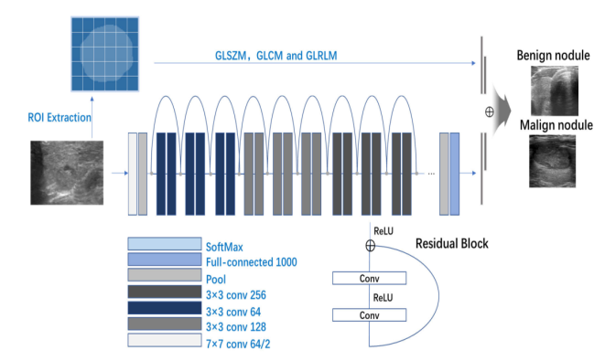

Fig.2: System architecture

**MODULES:**

To implement aforementioned project we have designed following modules

* Data exploration: using this module we will load data into system
* Processing: Using the module we will read data for processing
* Splitting data into train & test: using this module data will be divided into train & test
* Model generation: Building the models
* User signup & login: Using this module will get registration & login
* User input: Using this module will give input for prediction
* Prediction: final predicted displayed

**4. IMPLEMENTATION**

**Feature Fusion ResNet:**

For the proposed model to use however many elements as plausible for the ensuing characterization, highlight combination alludes to the combination of component vectors of preparing pictures recovered from shared weight network layer with include vectors comprising of other mathematical information. The "character alternate route association" laid out by ResNet's counterfeit brain network permits the model to exclude at least one layers. With this strategy, preparing the organization on a large number of levels might be managed without compromising execution.

**Feature Fusion VGG16:**

A convolutional neural network with 16 layers is called VGG-16. The ImageNet data set contains a pretrained form of the organization that has been prepared on in excess of 1,000,000 photographs. The prepared organization can distinguish photographs in 1000 different item classifications, including various creatures, a console, a mouse, & more.

**VGG16 with Feed Forward Network Transfer Learning:**

The 16-layer move learning engineering VGG16 is somewhat like going before designs in that CNN alone fills in as its just groundwork, albeit the arrangement is marginally unique. For this design, the scientists utilized a traditional information picture size of 224*224*3, where 3 represents the RGB channel.

**ResNet50:**

A convolutional neural network with 50 layers is called ResNet-50. The ImageNet information base contains a pretrained variant of the organization that has been prepared on in excess of 1,000,000 photographs. The prepared organization can recognize photographs in 1000 different item classes, including various creatures, a console, a mouse, & more.

**VGG16:**

A convolutional neural network with 16 layers is called VGG-16. The ImageNet data set contains a pretrained variant of the organization that has been prepared on in excess of 1,000,000 photographs. The prepared organization can distinguish photographs in 1000 different item classifications, including various creatures, a console, a mouse, & more.

**MobileNet V2:**

A convolutional neural organization of 53 layers profound is called MobileNet-v2. The ImageNet data set contains a pretrained rendition of the organization that has been prepared on in excess of 1,000,000 photographs. The prepared organization can distinguish photographs in 1000 different item classes, including various creatures, a console, a mouse, & more.

**GAN:**

In a machine learning (ML) model called a generative adversarial network (GAN), two brain networks battle with each other to make expectations that are more right. GANs commonly work solo & learn through agreeable lose situations.

**KNN:**

The k-nearest neighbours calculation, at times alluded to as KNN or k-NN, is a directed learning classifier that utilizes vicinity to deliver characterizations or expectations about the gathering of a solitary piece of information.

**LR:**

In view of a few ward factors, the AI characterization process known as strategic relapse is utilized to gauge the probability of a given class. Generally, the strategic relapse model works out the calculated of the result by figuring the amount of the information highlights (by & large, there is an inclination term).

**Voting Classifiers:**

A democratic classifier is a sort of AI assessor that fosters various base models or assessors & makes expectations in view of averaging their outcomes. Deciding in favor of every assessor result can be coordinated with the collecting models.

**5. EXPERIMENTAL RESULTS**

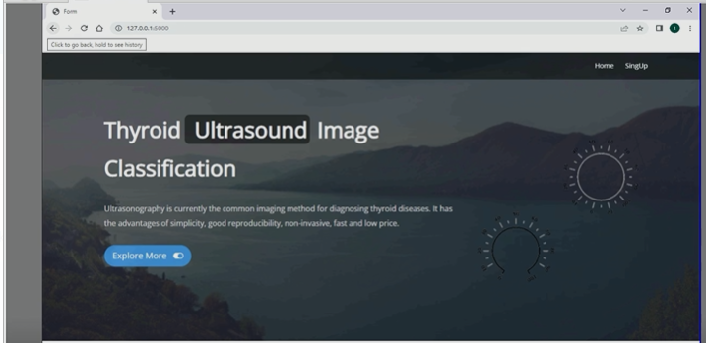

Fig.4: Home screen

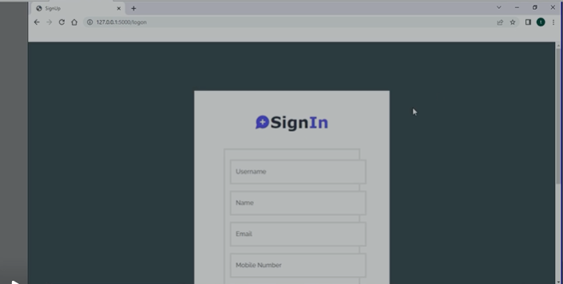

Fig.5: Signup

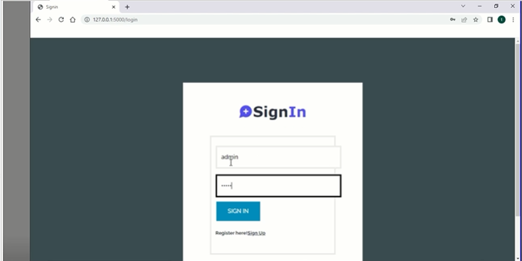

Fig.6: Signin

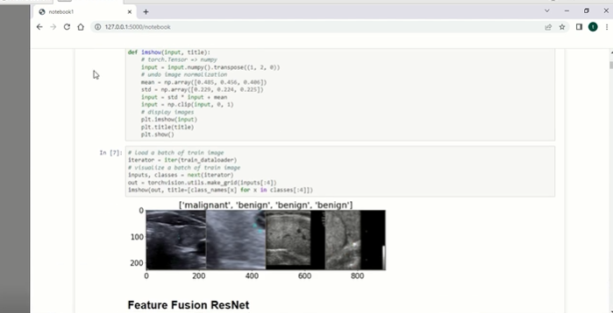

Fig.7: Features fusion resnet

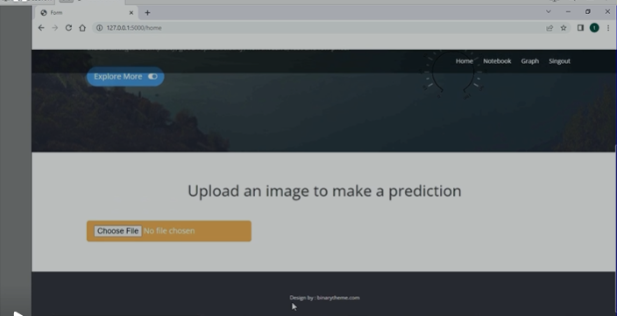

Fig.8: Upload image

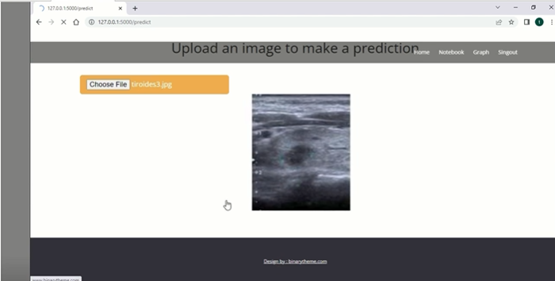

Fig.9: Image loaded

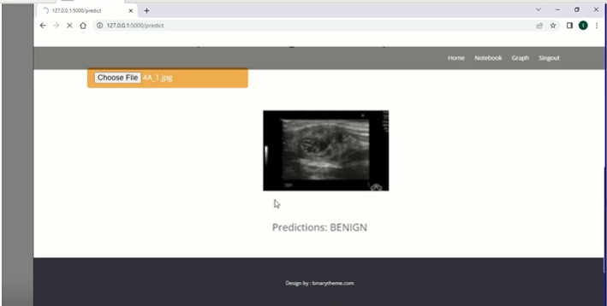

Fig.10: Prediction

**6. CONCLUSION**

This work tries to assist specialists with making a clinical conclusion of thyroid knobs, subsequently improving the exactness & effectiveness of determination. Clinical ultrasonography ID of harmless & threatening thyroid knobs is an emotional & tedious cycle. The clinically assembled information should initially go through preprocessing, which incorporates trimming, improving, & removing areas of interest. Then, at that point, contingent upon the knobs' region, include designing is utilized to separate the surface qualities of the knobs, & element dimensionality decrease is achieved by relating the highlights & knobs. To additional upgrade network execution, a profound brain network model is fabricated & surface highlights from the past stage are joined. This approach had the best exhibition in the assessment of 1874 thyroid knob patients & has clinical potential. This article presents an original technique for intertwining highlights & consolidates the advantages of component designing & profound brain organizations. This work can be appropriate to numerous spaces under the exchange learning & combination highlight structure, like bosom knobs, lung knobs, & other growth analysis, in spite of the way that its essential spotlight is on approving the analytic execution of ultrasound imaging of thyroid knobs. It means quite a bit to take note of that the motivation behind the technique for combining highlights is essentially to furnish the profound brain network with additional elements & data so the organization can unite all the more unequivocally & quicker. Future examination on new combination data may likewise go in this course. This study draws motivation from different fields, including profound convolutional networks, picture examination, & PC supported diagnostics.

**REFERENCES**

[1] J. Kim, J. E. Gosnell, & S. A. Roman, ‘‘Geographic influences in the global rise of thyroid cancer,’’ Nature Rev. Endocrinol., vol. 16, no. 1, pp. 17–29, Jan. 2020.

[2] H. R. Shahraki, S. Pourahmad, S. Paydar, & M. Azad, ‘‘Improving the accuracy of early diagnosis of thyroid nodule type based on the SCAD method,’’ Asian Pacific J. Cancer Prevention, vol. 17, no. 4, pp. 1861–1864, Jun. 2016.

[3] J. Xu, M. Jing, S. Wang, C. Yang, & X. Chen, ‘‘A review of medical image detection for cancers in digestive system based on artificial intelligence,’’ Expert Rev. Med. Devices, vol. 16, no. 10, pp. 877–889, Oct. 2019.

[4] H. Ye, J. Hang, X. Chen, D. Xu, J. Chen, X. Ye, & D. Zhang, ‘‘An intelligent platform for ultrasound diagnosis of thyroid nodules,’’ Sci. Rep., vol. 10, no. 1, Aug. 2020, Art. no. 13223.

[5] L. Wang, S. Yang, S. Yang, C. Zhao, G. Tian, Y. Gao, Y. Chen, & Y. Lu, ‘‘Automatic thyroid nodule recognition & diagnosis in ultrasound imaging with the YOLOv2 neural network,’’ World J. Surg. Oncol., vol. 17, no. 1, p. 12, Jan. 2019.

[6] C. Chen, L. Zhan, X. Pan, Z. Wang, X. Guo, H. Qin, F. Xiong, W. Shi, M. Shi, F. Ji, Q. Wang, N. Yu, & R. Xiao, ‘‘Automatic recognition of auditory brainstem response characteristic waveform based on bidirectional long short-term memory,’’ Frontiers Med., vol. 7, Jan. 2021, Art. no. 613708.

[7] D. Koundal, S. Gupta, & S. Singh, ‘‘Computer aided thyroid nodule detection system using medical ultrasound images,’’ Biomed. Signal Process. Control, vol. 40, pp. 117–130, Feb. 2018.

[8] D. Koundal, S. Gupta, & S. Singh, ‘‘Automated delineation of thyroid nodules in ultrasound images using spatial neutrosophic clustering & level set,’’ Appl. Soft Comput., vol. 40, pp. 86–97, Mar. 2016.

[9] Y. Zheng, S. Xu, Z. Zheng, L. Wu, L. Chen, & W. Zhan, ‘‘Ultrasonic classification of multicategory thyroid nodules based on logistic regression,’’ Ultrasound Quart., vol. 36, no. 2, pp. 149–157, Jun. 2020.

[10] W. Sun, S. Xie, J. Yu, L. Niu, & W. Sun, ‘‘Classification of thyroid nodules in ultrasound images using deep model based transfer learning & hybrid features,’’ in Proc. IEEE Int. Conf. Acoust., Speech Signal Process. (ICASSP), Mar. 2017, pp. 919–923.